**Stop Groups**

***Work-flow to Use Stop Groups***

Use **Add Preference** to obtain a baseline dialog that sets a named Stops Group



Repeat **Add Preference** for additional instances of the baseline dialog



***Preference Overview***

This preference sets up named Stops Groups. They are used for example, so set up Duty

Terminal Stops and Relief Points.

***Add Preference Dialog***

**Prerequisites:** None.

**Opening Dialog:**

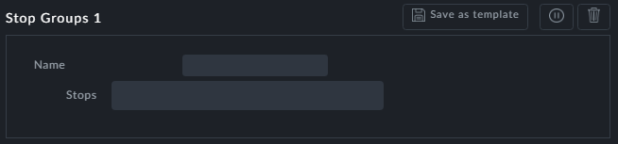

**Points to note:**

**Name**: Enter a name for the group. The name will be used in reports. Further, they will be available by name to preferences requiring Stop Groups.



**Stops**: You will be shown a drop-down list of available stops.

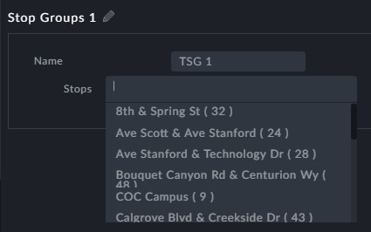

Choose as many as you need by clicking them.

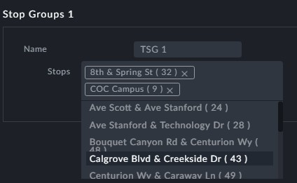

You may use **Add Preferences** to create additional Stop Groups

